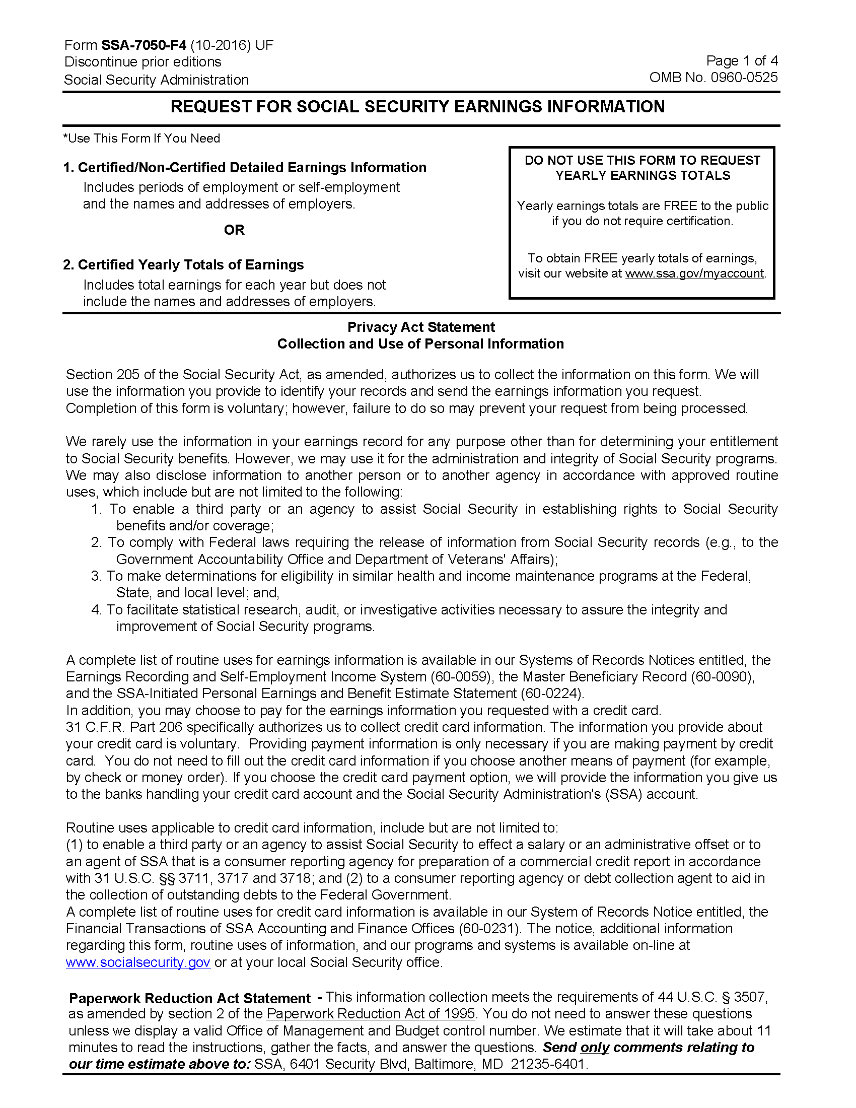
Order No. 01-29018 - 002 -- Contact:

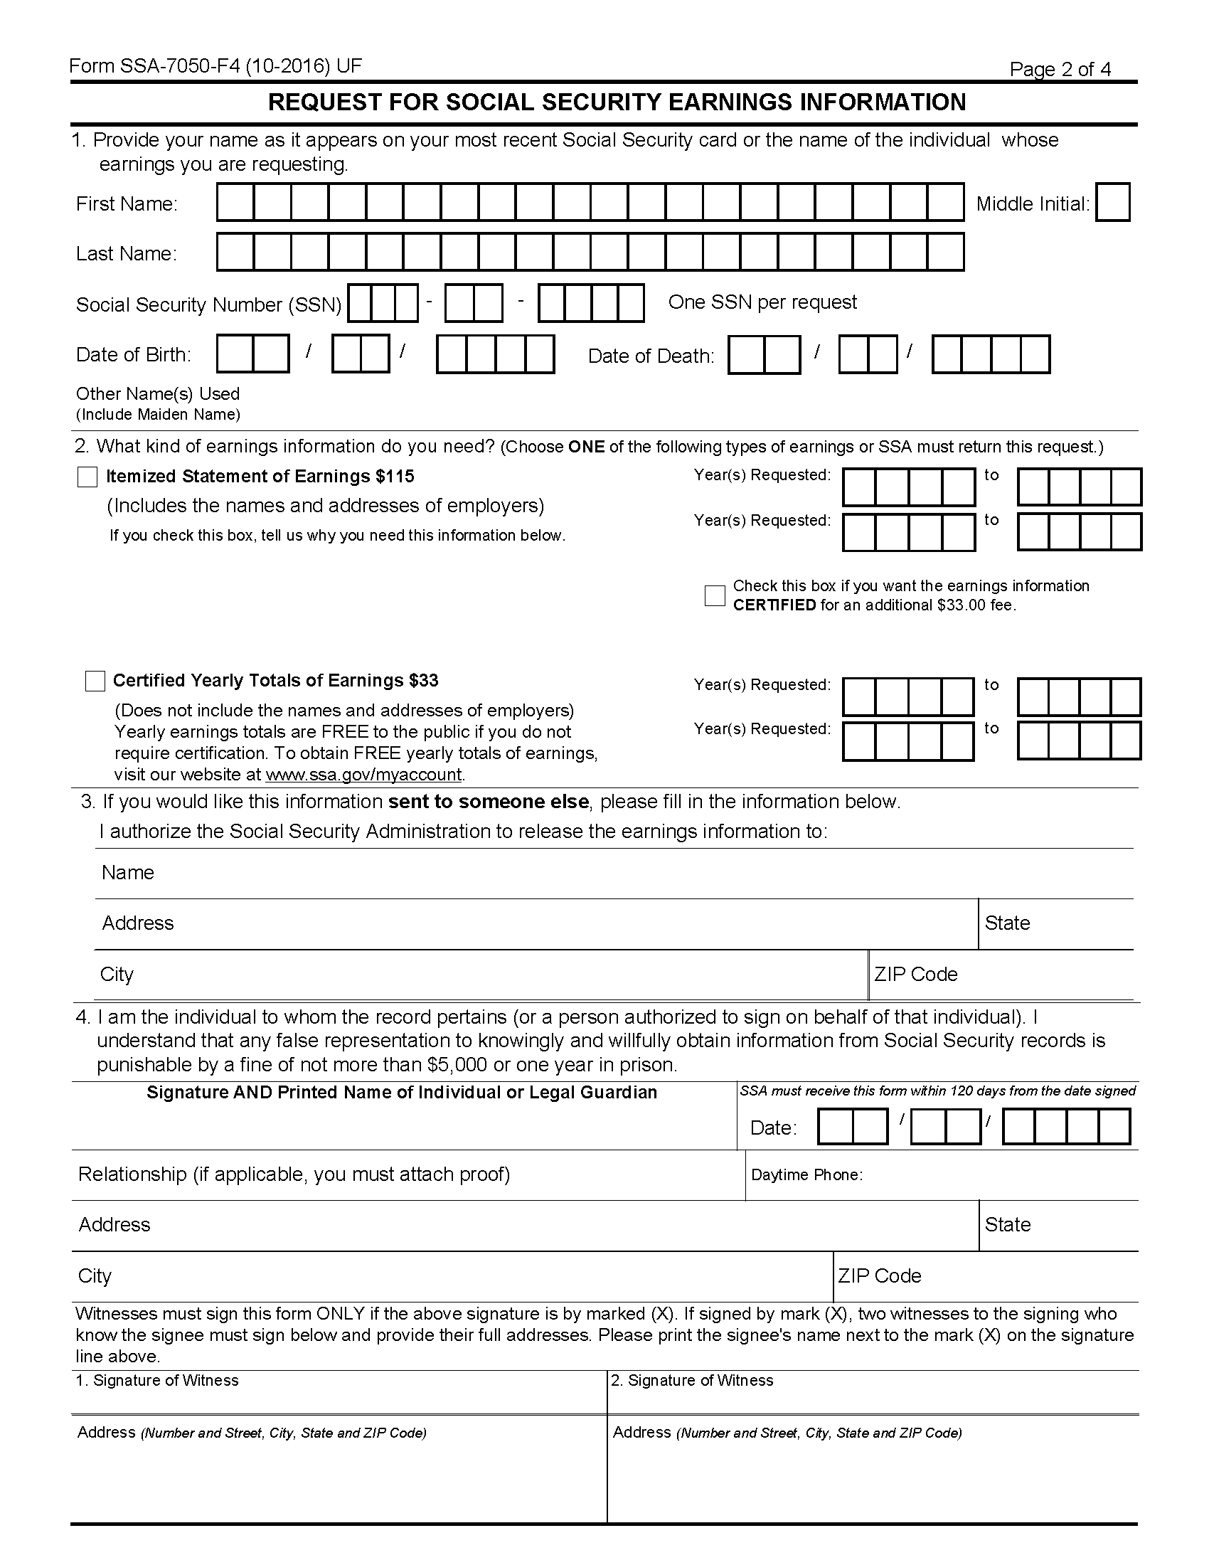
Order No. 01-29018 - 002 -- Contact:
Batman
xxx-xx-5555
01/01/1979

Axiom Requisition Copy Service
2869 Jolly Road
Okemos
MI
48864

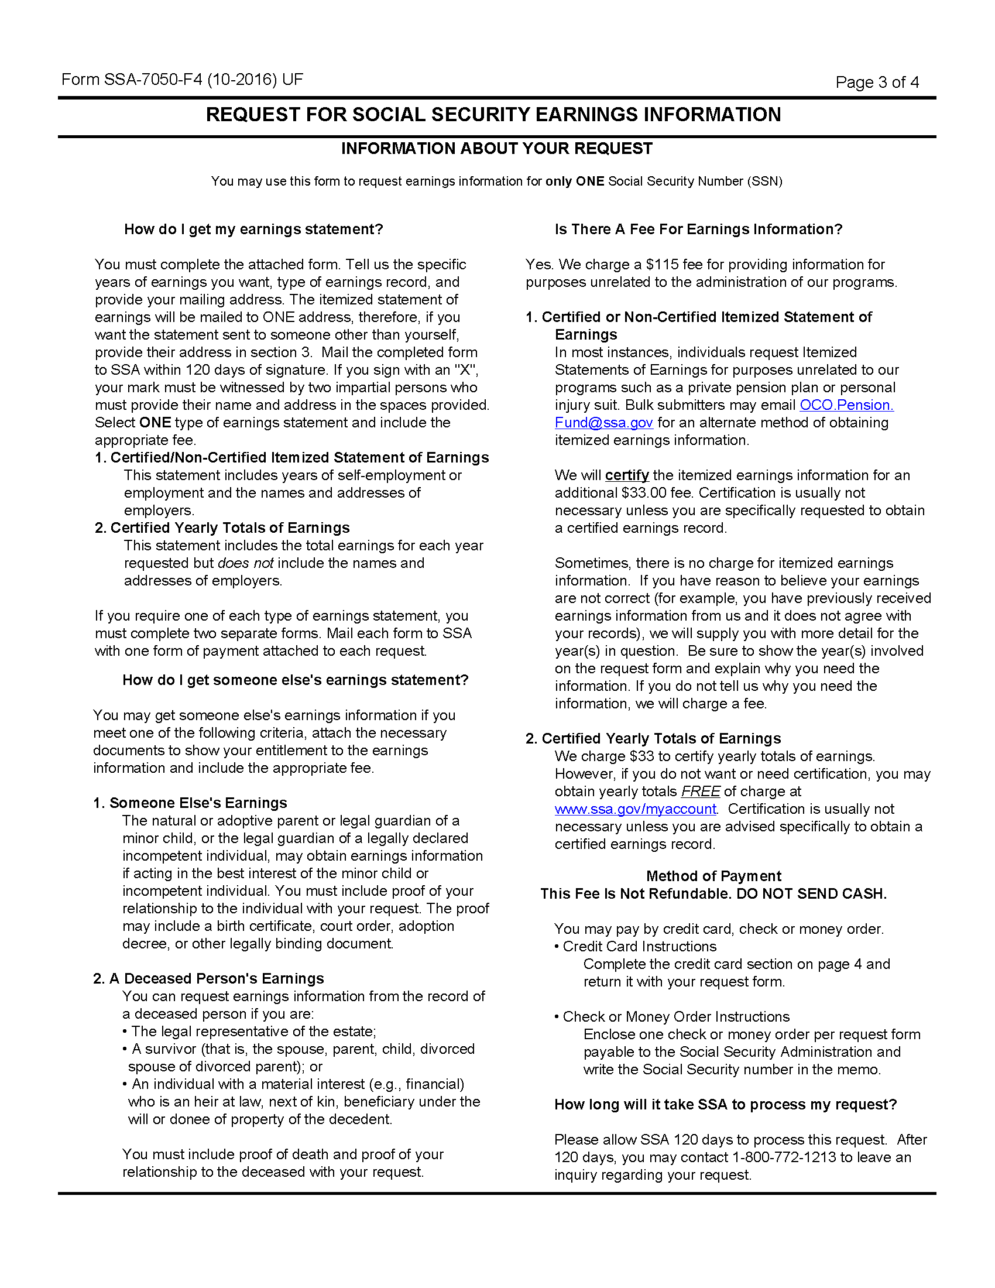
Order No. 01-29018 - 002 -- Contact:
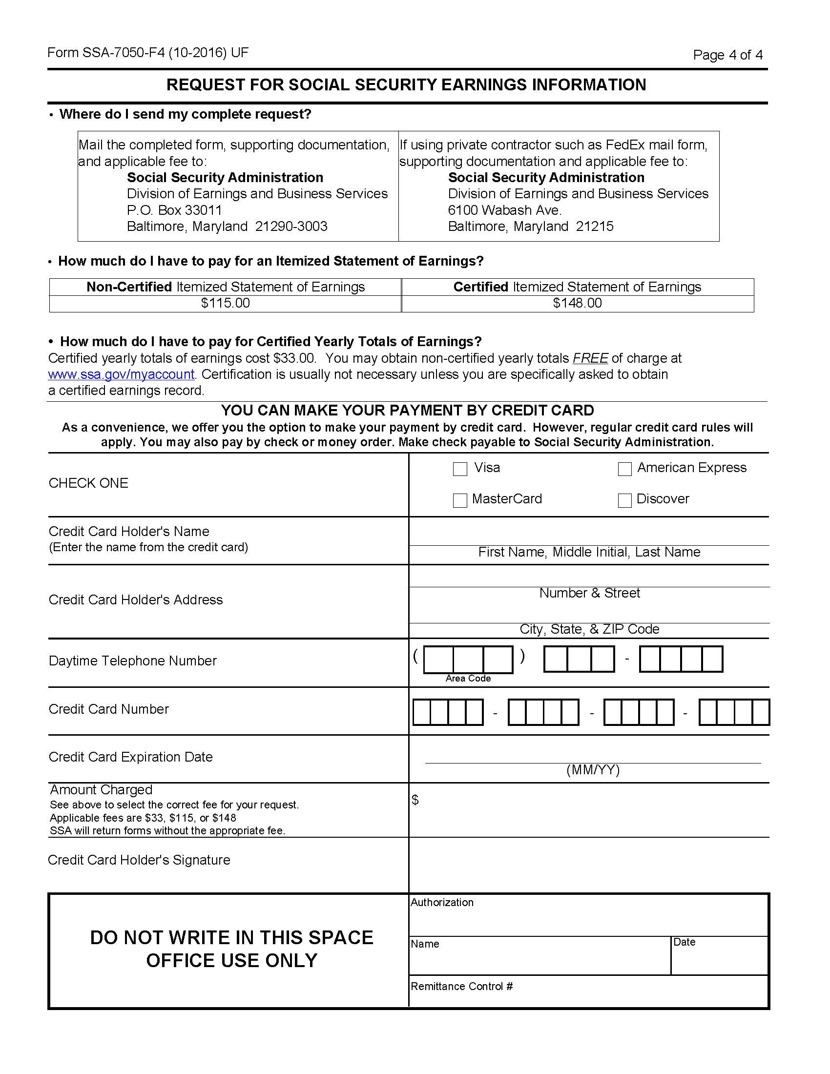
Order No. 01-29018 - 002 -- Contact:

